Contents
Changes to Existing Reports/Shared Datasets 2
Raising a Change Request 2
1. Fill in form fields 2
2. Fill in Change Detail section 3
3. Add tasks 5
Implementing a Change in QA 7
1. Complete the QA tasks 7
2. Obtain change approval 8
Implementing a Change in LIVE 11
1. Complete the LIVE task 11
2. Update the change status 12
3. Complete the linked incident 13
Requests for New Reports/Shared Datasets 15
Requesting a New Report/Shared Dataset 15
1. Fill in form fields 15
2. Fill in Change Detail section 15
3. Add tasks 16
Implementing a New Report/Shared Dataset in QA 17
1. Complete the QA tasks 18
2. Obtain change approval 18
Implementing a New Report/Shared Dataset in LIVE 18
1. Complete the LIVE task 19
2. Update the change status 19
3. Complete the linked incident 19

Additional Guidance
Knowledge Article: not yet written
HOW TO - Manage Reports - HR Reporting Environments.docx
HOW TO - Manage Reports - Access Permissions within HR Reporting.docx
HOW TO - Manage Reports - Parameters.docx
HOW TO - Manage Reports - Release and Deployment.docx
HOW TO - Manage Reports - Shared Data Sources.docx
HOW TO - Manage Reports - Shared Datasets.docx
HOW TO - Manage Reports - Troubleshoot Common Errors.docx
HOW TO - Manage Reports - Visual Studio Basics.docx

Context
This document details the formal change management process in OSM which must be used for implementing changes to SSRS reports and shared datasets (including the creation & deployment of new SSRS reports and shared datasets). Please refer to the Knowledge Article for additional details on who must be consulted and informed about such changes, and what downstream processes/services a report change may impact.

Changes to Existing Reports/Shared Datasets
 | The processes below refer to reports (.RDL files), but are the same for any changes to shared datasets (.RSD files). If you are amending a shared dataset, you should edit the text of the change request and linked tasks as follows:  - All references to “report” should be amended to “shared dataset”.  - All references to “.RDL file(s)” should be amended to “.RSD file(s)”.  - All references to [REPORT NAME] or [REPORT TAB] should be amended to the name of the shared dataset (e.g. LOV_Optional_EmployeeStatus.rsd).  Footnotes have been added throughout the guidance to remind you of when such amendments may be required.

Raising a Change Request

Fill in form fields
Log into OSM and go to the incident which you are using as the basis for your change request. Select the Change tab from the ribbon and click the button for “New Change”:

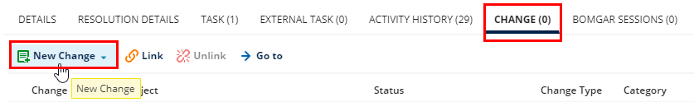

The New Change window will pop up. Complete the header fields as follows:

Field | Comment
Coordinator | Enter your name.
Service Line | Professional Services and University Admin
Service | HRIS
Category | HR Reporting
Approval Expiry Date | Set the deadline by which you require change approval.

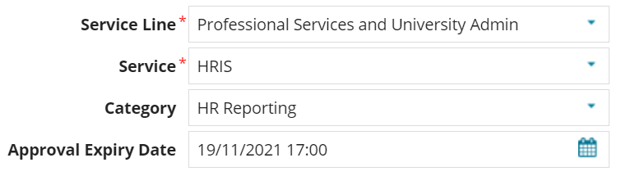

 | You must not implement your change in the LIVE environment until you have received change approval. If your change is time-sensitive (e.g. you need to implement it before next Friday), you should set an Approval Expiry Date which will ensure that you receive approval in time to implement your change before the deadline.

In the Classification section, complete the fields as follows:

Field | Comment
Status | Logged (this field is pre-populated)
Type | Minor (this field is pre-populated)
Justification | Report

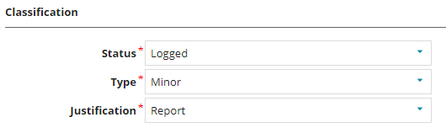

In the Schedule Detail section, confirm when you intend to implement your change, and how long you expect implementation to take:

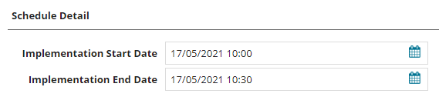

 | Your Implementation Start/End Dates must come after the Approval Expiry Date. If you have a sense of how long it will take to complete a change, you can be precise about the time-stamps, but it’s not necessary to be exact, here.

Fill in Change Detail section
The Change Detail section is where you must record exactly what you are changing, why you are changing it, and what the potential impact(s) of your change may be.

In the “Summary” field, enter the phrase REPORT CHANGE: [Name of the report you are changing] :

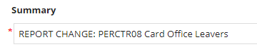

In the “Description” field, complete the 14-part questionnaire as shown. Remember to amend the answers as necessary if you are changing a dataset rather than a report.

Question | Answer
- Details - What is changing? | Provide a brief explanation of what you are changing, and if possible, include the current SQL code and the new (amended) SQL code.  If you have made extensive changes to the SQL, it’s helpful to attach two .TXT files to your change: one containing the unchanged SQL, and one containing the amended SQL. If you do this, you should say “Refer to attachments” in your change description, rather than providing the SQL code inline.
- Justification - Why is the change necessary? | Changes to reports are usually required to fix problems, e.g. error messages or a failure to return all the expected data – in those cases, the justification is “To resolve [brief description of problem]”. If there is a linked Incident, refer to it by number, i.e. “See linked Incident #X for details.”  If the request is for an enhancement rather than a “break-fix” request, then the justification should be provided on the Enhancement Form that users are required to submit.
- Related Changes - Are there dependent changes? | If there are related changes, list them here by Change ID number; otherwise, put “No dependent changes”.
- Impact on dependent services? What is the impact on connected or downstream services or components? | If changing a report will have an impact on downstream services such as system integrations or HR processes (e.g. Payroll things), it’s worth detailing the impact here. Normally, however, you can just put “No impact on services”.
- Impact - Specify downtime or at risk period | No downtime or at-risk period is entailed by a change to a report, so you can put “N/A”.
- Impact - Effect of not applying the change? | Explain the problem which led to the report change, e.g. “Users will be unable to run the report successfully” or “Report will not return Fixed Term employees”.
- Risk Assessment - What are the risks to the services? | It is very unlikely that a report change will ever pose a risk to services, so you can normally just put “N/A” here.
- Testing - Who will test it and how? | The HRIS Functional Analyst / Senior HR Analyst will make the change outlined above in the HR Reporting QA solution and deploy the amended .RDL file to the HR Reporting QA server.  The change requestor [normally whoever raised the incident] will be given a link to the amended .RDL in the QA server and asked to confirm whether they are now seeing the expected results.
- Implementation Plan - Who will implement it and how? | Once testing is successfully completed, the HRIS Functional Analyst / Senior HR Analyst will deploy the amended .RDL file to the HR Reporting LIVE server and archive the old version in the _Back-up Versions folder on that server.
- Communications Plan – Who needs to know and how? | In most cases, only the person who asked for the change will need to know when the change has been implemented. However, for very large or widely-used reports, e.g. PERDEP01 or HRINFO01, it’s very important to communicate the changes more widely. Speak to the HR Systems Business Change Analyst (Tonya Iasisen-Kandola) if you’re ever unsure about how a change should be communicated – if necessary, she can ensure comms are sent out to anyone who needs to know.
- Business Owner/Approver | (Head of HR Systems)
- What is the potential security impact of the change? | None.
- How will the security impact be tested? | N/A
- Back Out Plan - How will it be backed out in the event of the change failing? | The previous version of the report can be restored from the _Back-up Versions folder on the LIVE server.

When you have completed the Change Details section, click the “Save” button at the bottom of the New Change window to make your change live:



The screen will refresh, and the New Change window will close. Your change request will appear as shown below, with an official request number. Click “Go to” to be taken to your change request:

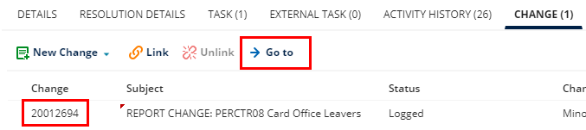

Add tasks
Go to your change request and select Task from the ribbon. Click “New Task” to create a new task:

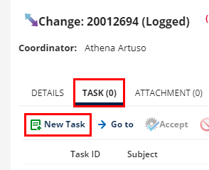

The New Task window will pop up. Complete the fields as shown below:

Field | Comment
Team | Select your team from the drop-down.
Owner | Enter your name.
Service Line | Professional Services and University Admin
Service | HRIS
Category | HR Reporting

In the “Summary” field, enter the task summary. You will need to raise three standard tasks for any report or dataset change. Template text (including task summaries) is provided below; modify this as required for each task.

QA: Update the .RDL file(s)
Amend [REPORT TABS] as detailed in the change summary and save all the files in the [REPORT NAME] suite as a new major version (#.0). Deploy the new _v# versions of the .RDLs to the HR Reporting QA server.

QA: Archive old versions
Archive the old (version #.0) copies of the [REPORT NAME] .RDL files in the _Back-up Versions folder of the HR Reporting QA server, and make a note on each .RDL indicating when it was archived.

LIVE: Update the .RDL file(s)
Once change approval has been granted, deploy all the updated (version #.0) .RDL files to the HR Reporting LIVE server to replace the existing version of the [REPORT NAME] .RDLs. Move the new versions into the [REPORT NAME] folder and delete the old versions from the HR Reporting LIVE server.

Your task pane for the change should now look something like this:

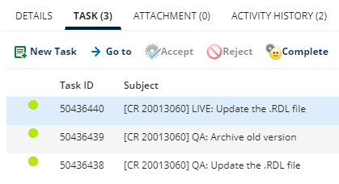

Implementing a Change in QA
After you’ve raised the change in OSM, you should make any amendments required to the report .RDL files/dataset .RSD files in Visual Studio.

Test the amended .RDL/.RSD files yourself to check that they are working as expected, and deploy them to the HR Reporting QA server. This is where the end-user who requested the change will perform user acceptance testing (UAT), and confirm whether or not the amended files are ready to be published to the HR Reporting LIVE server.

 | If the amended .RDL/.RSD files fail UAT, you must work with the end-user to modify the .RDLs/.RSDs until such time as the files return the results the end-user is expecting. Do not complete your tasks until the end-user has confirmed that the .RDLs/.RSDs have passed UAT.

Once the amended .RDL/.RSD files have passed UAT, you can complete the tasks on your change request, as shown below.

Complete the QA tasks
As you complete each task on the change, you must mark it “Complete” and add a note indicating what action you took to complete the task. Select the task you wish to mark “Complete” and click the Complete button:

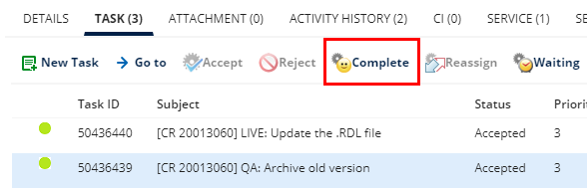

A small window will pop up where you can enter the details of the actions you took to complete the task.

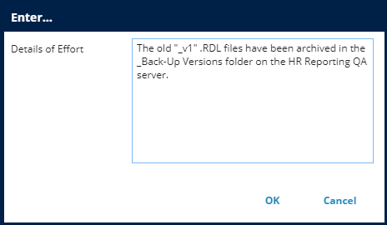

Click OK to save your changes. The task will now appear in the task pane with the status “Completed”:

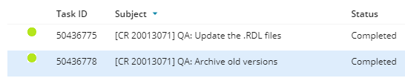

 | NB: You can’t modify a task once you have marked it “Complete”!

Template text for each task completion is provided below; modify this as required for each task as you complete it.

QA: Update the .RDL file(s)
The amendments described in the change summary have been made to the relevant .RDL files in the [REPORT NAME] suite, and all the .RDL files have been saved as "_v#" and deployed to the HR Reporting QA server.

QA: Archive old versions
The old "_v#" .RDL files have been archived in the _Back-Up Versions folder on the HR Reporting QA server.

 | STOP: You must now submit the change for formal approval. Do not take any further action until approval has been granted.

Obtain change approval
Once your amended .RDL/.RSD files have passed UAT and you have completed the QA tasks on your change request, you must obtain formal change approval. This is an essential part of change management – you should never make changes to the HR Reporting LIVE server without first getting formal approval for those changes.

Follow the steps below to prepare your change request for approval.

Assign a Service Approver
Go to your change request. At the top of the screen, select the button to Add Approver:

A pop-up box will open where you can enter the name of the Service Approver whose approval you require for your change (for reporting changes, the service owner – and therefore the service approver – is always the current Head of HR Systems):
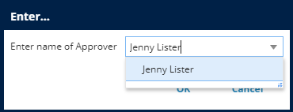

Click OK to assign the approver. At the top of the screen, you will need to click Save to commit your changes.

Check Approval Expiry Date
When you filled in the form fields for your change request, you set an Approval Expiry Date for your change – this is the deadline by which you require change approval. Report/dataset changes can sometimes require a lot of development, and the original Approval Expiry Date you set for your change may no longer be valid.

Once your amended .RDL/.RSD files have passed UAT and you are ready to request change approval, double-check your Approval Expiry Date and amend it if necessary.

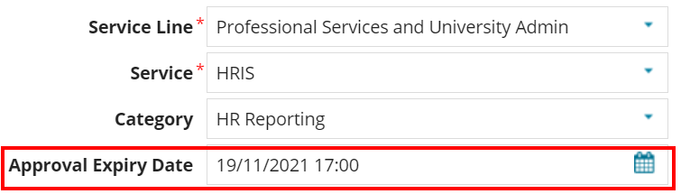

If you’ve changed the date, you will need to click Save at the top of the screen to commit the change.

Check Implementation Dates
When you filled in the form fields for your change request, you set Implementation Dates for your change, indicating when you intended to implement your change, and how long you expected implementation to take. As noted above, report/dataset changes can sometimes require a lot of development, so you may need to edit your original Implementation Start and End Dates to reflect when you will actually be implementing your change in the HR Reporting LIVE environment.

If you need to edit your Implementation Dates, go to the Schedule Detail section on the Change Summary and make the necessary changes:

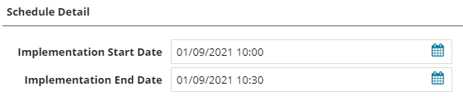

If you’ve made any changes to these dates, you will need to click Save at the top of the screen to commit them.

Submit change for approval
If you’re satisfied that the Approval Expiry Date and the Implementation Dates are correct, you are ready to submit your change for formal approval. To do this, simply amend the change’s Status to “Pending Approval” in the Classification section:

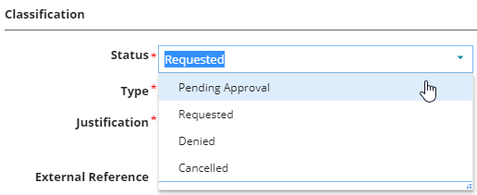

An email will be sent to the assigned Service Approver asking for them to formally approve the change.

When the Service Approver approves your change request, you will receive an email notification of the approval. Approving the change automatically updates the change’s status from “Pending Approval” to “Scheduled”, so you should receive an email notification for the approval and the change of status:

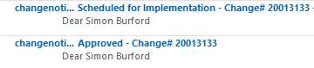

On OSM you will see the Status now appears as “Scheduled”:

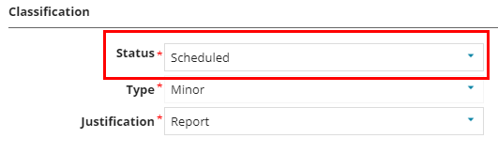

Implementing a Change in LIVE
Once you have received formal change approval and your change’s status is “Scheduled”, you are ready to implement your change in the HR Reporting LIVE environment.

Deploy the amended .RDL or .RSD files to the HR Reporting LIVE server and move them into the appropriate folder. You will need to delete the previous versions of the .RDLs/.RSDs from the server once the amended versions are in place (see HOW TO - Manage Reports - Release and Deployment.docx for details).

Complete the LIVE task
Select the relevant task from your task pane and click “Complete”:

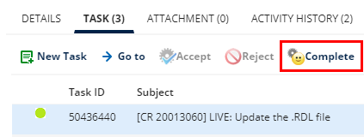

A small window will pop up where you can enter the details of the actions you took to complete the task.

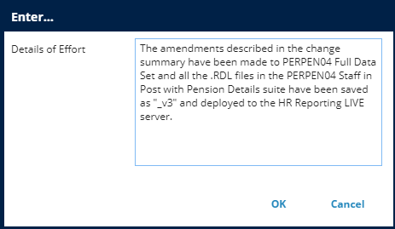

Click OK to save your changes.

Template text for the LIVE task completion is provided below; modify this as required for your task as you complete it.

LIVE: Update the .RDL file(s)
The amendments described in the change summary have been made to [REPORT TABS] and all the .RDL files in the [REPORT NAME] suite have been saved as "_v#" and deployed to the HR Reporting LIVE server.

Update the change status
After completing the final task on your change, you need to update the change Status twice: first, to “Implemented”, and second, to “Closed”.

In the Classification section of the change summary, amend the change’s Status from “Scheduled” to “Implemented”:

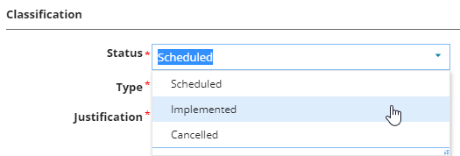

The screen will refresh. Now update the change’s Status from “Implemented” to “Closed”:

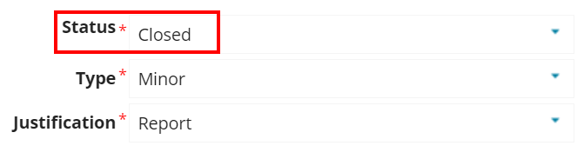

The change is now closed.

 | You can’t modify a change once you have marked it “Closed”, so be very sure that you don’t need to take any further action!

Complete the linked incident
Go to the Incident tab on the ribbon and select the incident which you used as the basis for your change request. Click “Go To” to be taken to the Incident record:

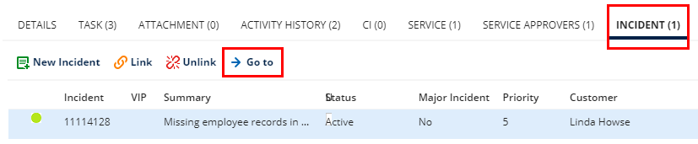

Go to the task pane on the Incident record, select the task, and click “Complete”:

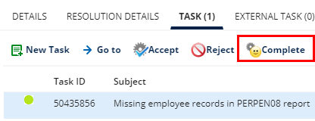

A small window will pop up where you can enter the details of the actions you took to complete the task.

 | You can complete the Incident task with the same text you used to complete the LIVE task on your change request. Just mention the change request ID number as well, as this is useful for future reference.

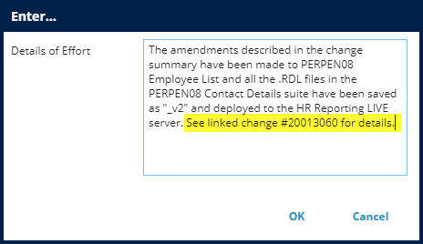

Click OK to save your changes.

Your change request for a report change is now complete!

Requests for New Reports/Shared Datasets
The change management process for requests for new SSRS reports and shared datasets is largely the same as the change management process for amendments to existing SSRS reports/datasets, but there are a few differences, which have been captured here.

Requesting a New Report/Shared Dataset

Fill in form fields
The guidance here is identical to the guidance given above.

Fill in Change Detail section
The Change Detail section is where you must record exactly what you are changing, why you are changing it, and what the potential impact(s) of your change may be. For a new report or shared dataset, you aren’t actually “changing” anything; you are simply adding a new report/dataset to the existing report catalogue. The information you provide in the Change Detail section will therefore be different to the information you would provide for a change to an existing report/dataset.

In the “Summary” field, enter the phrase NEW REPORT: [Name of the report you are creating]:

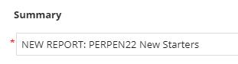

In the “Description” field, complete the 14-part questionnaire as follows (remember to amend the answers as necessary if you are creating a dataset rather than a report!):

Question | Answer
- Details - What is changing? | Provide the name and a brief description of the new report you are creating.
- Justification - Why is the change necessary? | New reports are usually created to facilitate system processes, particularly newer processes such as those introduced by projects or changes to legislation. Refer to the role of the requestor here, e.g. “Requested by Payroll Manager”, and copy the requestor’s comments from their request – they will normally have provided the justification within the comments. If there is a linked Incident, refer to it by number, i.e. “See linked Incident #X for details.”
- Related Changes - Are there dependent changes? | If there are related changes, list them here by Change ID number; otherwise, put “No dependent changes”.
- Impact on dependent services? What is the impact on connected or downstream services or components? | If the new report is intended to have an impact on downstream services such as system integrations or HR processes (e.g. Payroll things), it’s worth detailing the impact here. Normally, however, you can just put “No impact on services”.
- Impact - Specify downtime or at risk period | No downtime or at-risk period is entailed creating a new report, so you can put “N/A”.
- Impact - Effect of not applying the change? | This is the reason the new report is required, e.g. “Payroll will be unable to report on data for furloughed workers without the new report”.
- Risk Assessment - What are the risks to the services? | It is very unlikely that creating a report will ever pose a risk to services, so you can normally just put “N/A” here.
- Testing - Who will test it and how? | The HRIS Functional Analyst / Senior HR Analyst will create the new report outlined above in the HR Reporting QA solution and deploy the .RDL files to the HR Reporting QA server so that they may be tested.  The change requestor [normally whoever raised the incident] will be given a link to the new report in the QA server and asked to confirm whether they are happy with the report or if it requires further development before it can be published to the LIVE server.
- Implementation Plan - Who will implement it and how? | Once testing is successfully completed, the HRIS Functional Analyst / Senior HR Analyst will deploy the new report to the HR Reporting LIVE server.  NB: A new folder will need to be created on the LIVE server to house the .RDL files for the new report, so the report’s position in the HR Reporting folder hierarchy must be determined, and the appropriate access permissions must be applied, before the report is moved to the LIVE folder.
- Communications Plan – Who needs to know and how? | In most cases, only the person who asked for the change will need to know when the change has been implemented. However, for reports which will be used by a large user-base (such as reports developed during projects), it’s very important to communicate the changes more widely. Speak to the HR Systems Business Change Analyst (Tonya Iasisen-Kandola) if you’re ever unsure about how a change should be communicated – if necessary, she can ensure comms are sent out to anyone who needs to know.
- Business Owner/Approver | (Head of HR Systems)
- What is the potential security impact of the change? | None.
- How will the security impact be tested? | N/A
- Back Out Plan - How will it be backed out in the event of the change failing? | The report can be removed from the HR Reporting LIVE server.

Add tasks
The guidance for adding tasks to a change is the same as that given above, however the tasks themselves are a little different when you’re creating a new report/shared dataset. See below for details.

You will need to raise three standard tasks when creating a new report/shared dataset. Template text (including task summaries) is provided below; modify this as required for each task.

Determine folder permissions
Confirm where in the HR Reporting folder hierarchy the new report should be filed (e.g. Personnel > Current Reports, or Payroll > Payroll Processing, etc.), and which reporting AD groups should have access to the new report. Create a new folder for [REPORT NAME] in both the HR Reporting QA and HR Reporting LIVE servers, and assign the confirmed AD groups to the folder in both locations.

QA: Create the .RDL files
Create an .RDL file for each of the [REPORT TABS] as detailed in the change summary and save all the files in the [REPORT NAME] suite as major version 1.0. Deploy the .RDLs to the [REPORT NAME] folder on the HR Reporting QA server.

LIVE: Publish the .RDL file(s)
Once change approval has been granted, deploy the .RDL files to [REPORT NAME] folder on the HR Reporting LIVE server.

Implementing a New Report/Shared Dataset in QA
After you’ve raised the change in OSM, you should create the new .RDL or .RSD files in Visual Studio (see linked guide tbc).

Test the .RDL/.RSD files yourself to check that they are working as expected, based on the end-user’s request; then deploy them to the HR Reporting QA server. This is where the end-user who requested the new report will perform user acceptance testing (UAT), and confirm whether or not the new report is ready to be published to the HR Reporting LIVE server.

 | If the new report/dataset fails UAT, you must work with the end-user to modify the report or dataset until such time as the files return the results the end-user is expecting. Do not complete your tasks until the end-user has confirmed that the report/dataset has passed UAT.

Once the new report/dataset has passed UAT, you can complete the tasks on your change request.

Complete the QA tasks
The guidance for completing the tasks for a new report or shared dataset is the same as that given above, however the template text for completion is a little different when you’re creating a new report/dataset; modify this as required for each task.

Determine folder permissions
A new folder for [REPORT NAME] has been created on the HR Reporting QA and HR Reporting LIVE servers, at the following location:

[folder path, e.g. Personnel > Current Reports]

The folder has been shared on both servers with the following AD groups:

[AD group 1 – e.g. HRIS-RR-PERDREP]
[AD group 2 – e.g. HRIS-RR-PAYMREP]

QA: Create the .RDL files
The following .RDL files in the [REPORT NAME] suite have been created as detailed in the change summary and saved as major version 1.0:

[REPORT TABS]

All the .RDLs have been deployed to the [REPORT NAME] folder on the HR Reporting QA server, where they can be tested.

 | STOP: You must now submit the change for formal approval. Do not take any further action until approval has been granted.

Obtain change approval
The guidance here is identical to the guidance for amending existing reports/datasets.

Implementing a New Report/Shared Dataset in LIVE
Once you have received formal change approval and your change’s status is “Scheduled”, you are ready to implement your change in the HR Reporting LIVE environment.

Deploy the .RDL or .RSD files for the new report/shared dataset to the HR Reporting LIVE server and move them into the appropriate folder.

Complete the LIVE task
The guidance for completing the tasks for a new report/shared dataset is the same as that given above, however the template text for completion is a little different when you’re creating a new report/shared dataset. See below for details.

LIVE: Publish the .RDL file(s)
The .RDL files for the new report have been deployed to the [REPORT NAME] folder on the HR Reporting LIVE server and the report requestor has been informed that the report is now available on the LIVE server.

Update the change status
The guidance here is identical to the guidance for Section 3.2.

Complete the linked incident
The guidance here is identical to the guidance for Section 3.3.

Your change request for a new report is now complete!

If you are changing a dataset, enter the phrase SHARED DATASET CHANGE: [Name of the dataset you are changing].
If you are changing a dataset, substitute “.RSD” for “.RDL” in your tasks and provide the dataset name (LOV_Optional_...). We don’t keep previous versions of .RSD files, so you can skip the task on archiving old versions, and ignore the text on [version #.0] in the two “Update” tasks.
If you are changing a dataset, substitute “.RSD” for “.RDL” in your tasks and provide the dataset name (LOV_Optional_...). We don’t keep previous versions of .RSD files, so you can skip the task on archiving old versions, and ignore the text on [version #.0] in the two “Update” tasks.
For reports, this will be the relevant report folder, e.g. PERDEP01 Staff in Post. For datasets, this will always be the Datasets (MASTER) folder.
If you are changing a dataset, substitute “.RSD” for “.RDL” in your tasks and provide the dataset name (LOV_Optional_...). We don’t keep previous versions of .RSD files, so you can ignore the text on [version #.0] in the “Update” task.
If you are creating a new shared dataset, enter the phrase NEW SHARED DATASET: [Name of the dataset you are creating].
If you are creating a dataset, substitute “.RSD” for “.RDL” in your tasks and provide the dataset name (LOV_Optional_...).
Not required for shared datasets. All shared datasets are stored in the Datasets (MASTER) folder in HR Reporting environments, and are locked down to the HR Reporting “super groups”.
If you are creating a dataset, substitute “.RSD” for “.RDL” in your tasks and provide the dataset name (LOV_Optional_...).
Not required for shared datasets. All shared datasets are stored in the Datasets (MASTER) folder in HR Reporting environments, and are locked down to the HR Reporting “super groups”.
For reports, this will be the relevant report folder, e.g. PERDEP01 Staff in Post. For datasets, this will always be the Datasets (MASTER) folder.

